**Air Quality Analysis and Prediction in Tamil Nadu**

**Phase 5- Documentation**

P. Kishore (411621104025)

Harish Prabhavathy (411621104014)

Kakimetla Prashant (411621104018)

A. Kaaleshwaran (411621104019)

G. Gokula Prasadth (411621104012)

**Introduction:**

Air quality is a crucial aspect of environmental health, impacting the well-being of individuals and communities. This project focuses on the development of an Air Quality Analysis and Prediction model using data science techniques in Python. As a student passionate about environmental sciences and data analytics, I embarked on this project to contribute to a cleaner and healthier environment.

**Importing Necessary Libraries:**

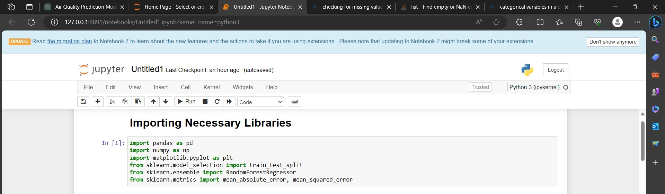

**Loading Of Dataset:**

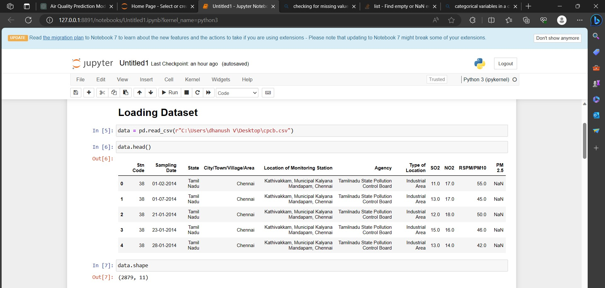

**Pre-Processing of Dataset:**

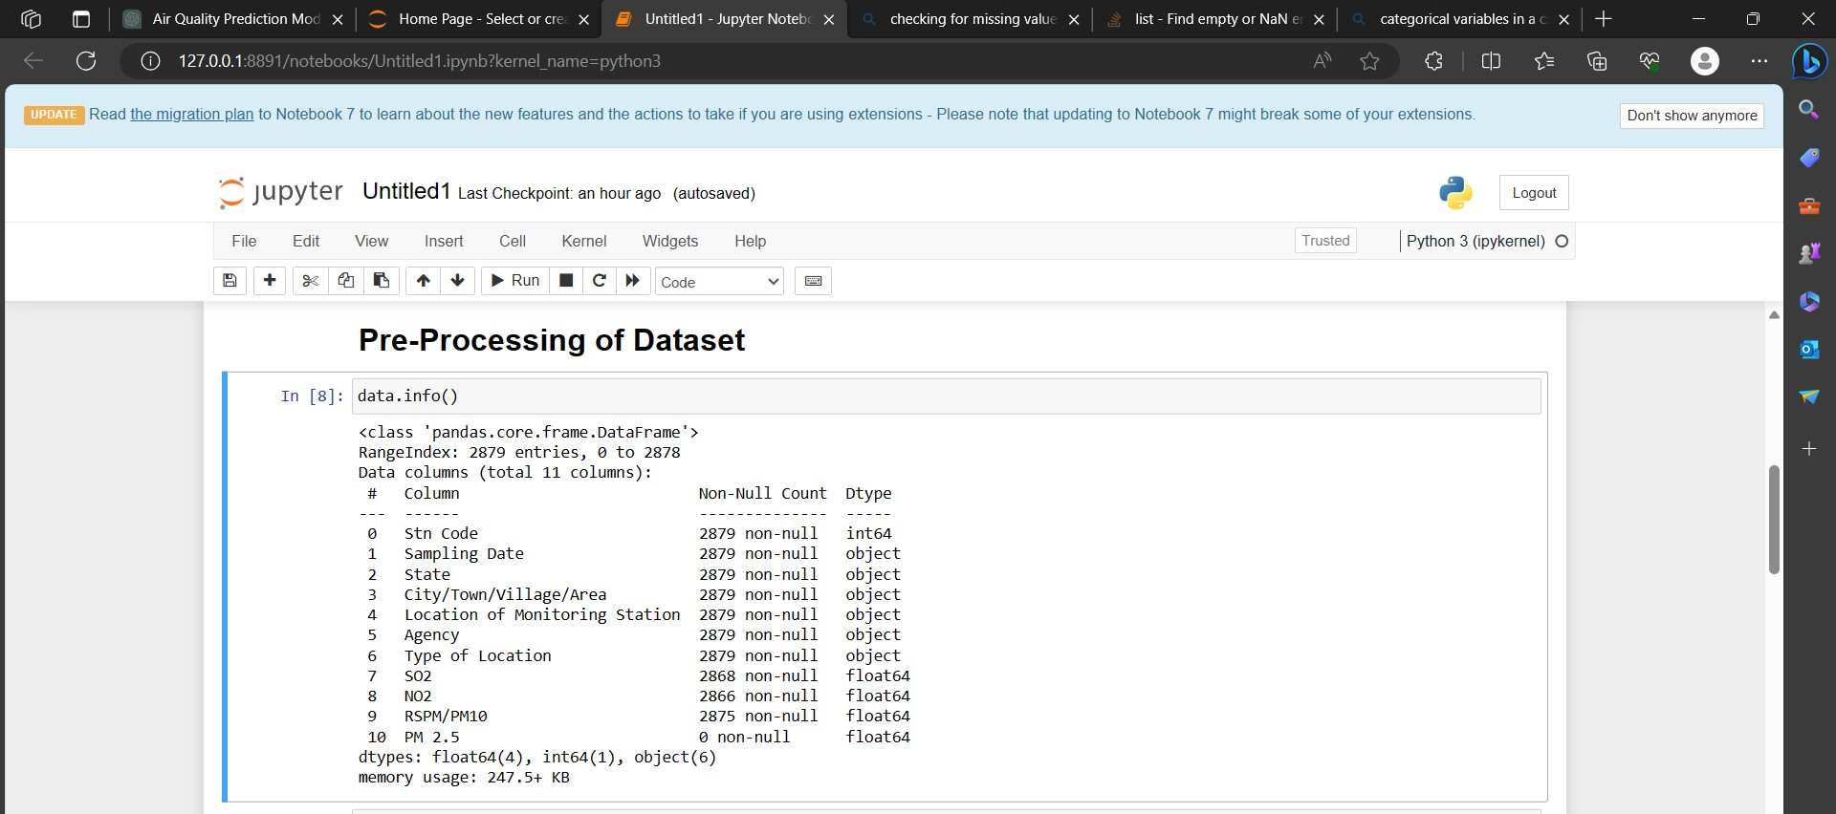

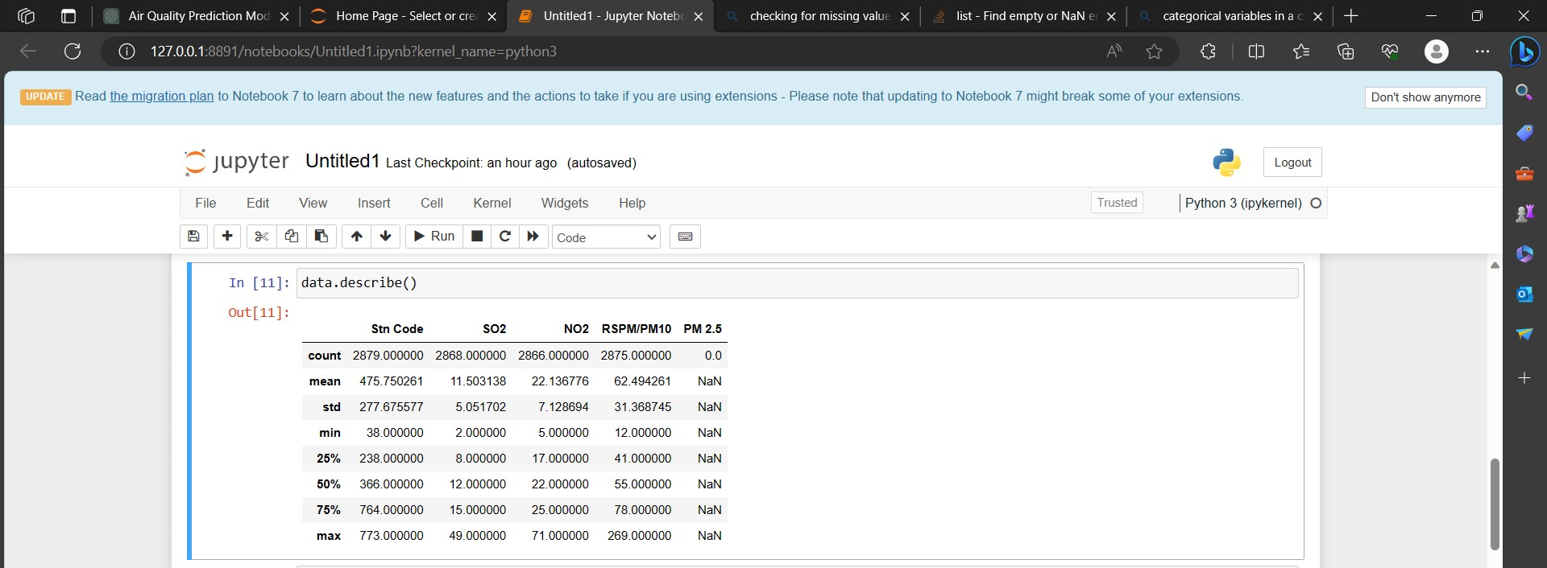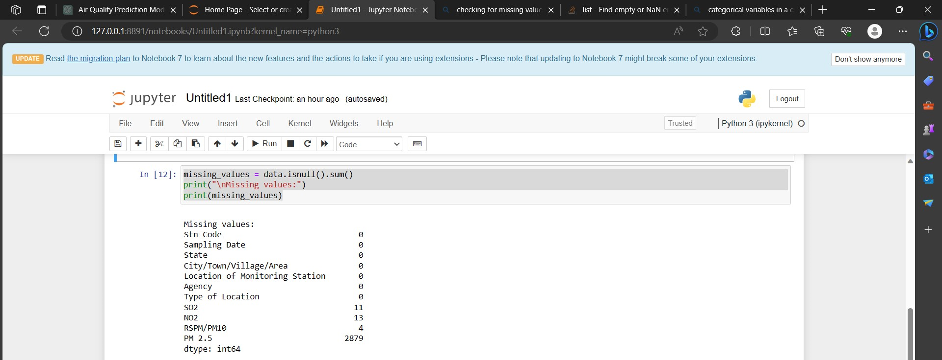

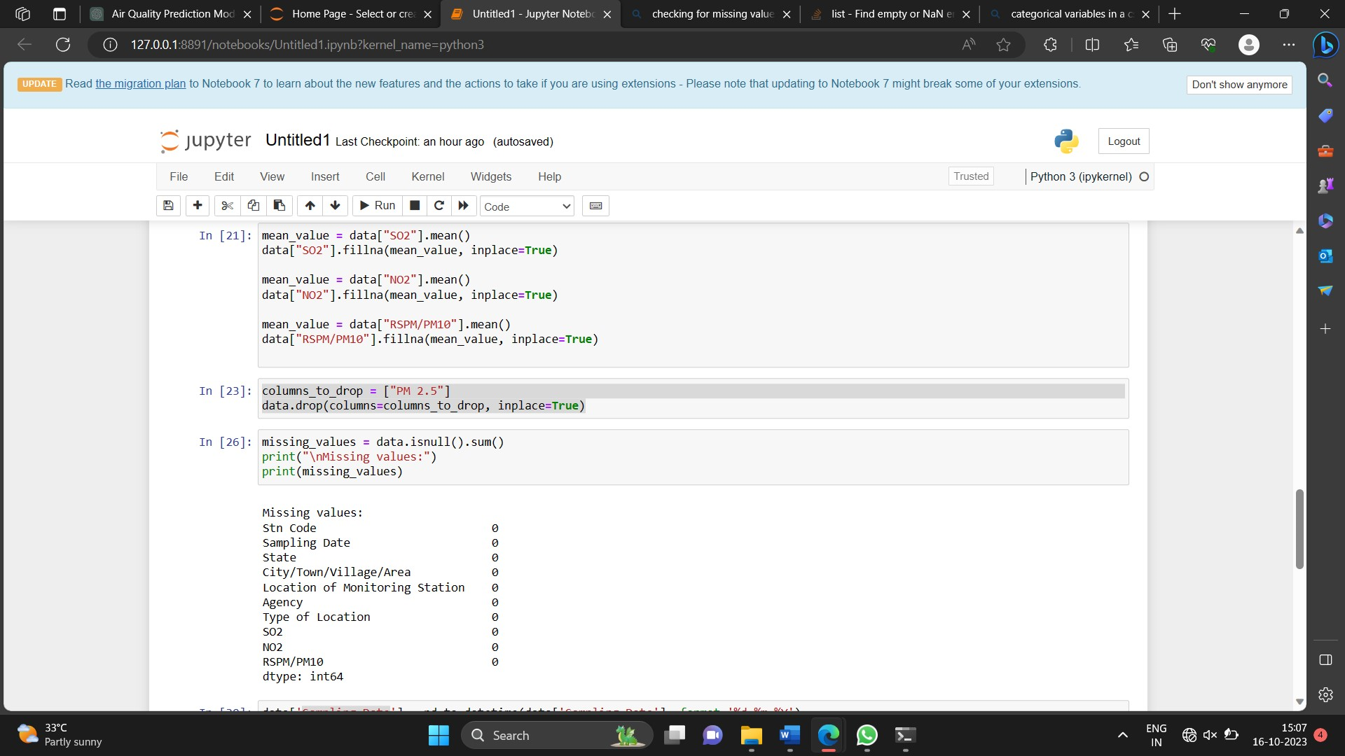

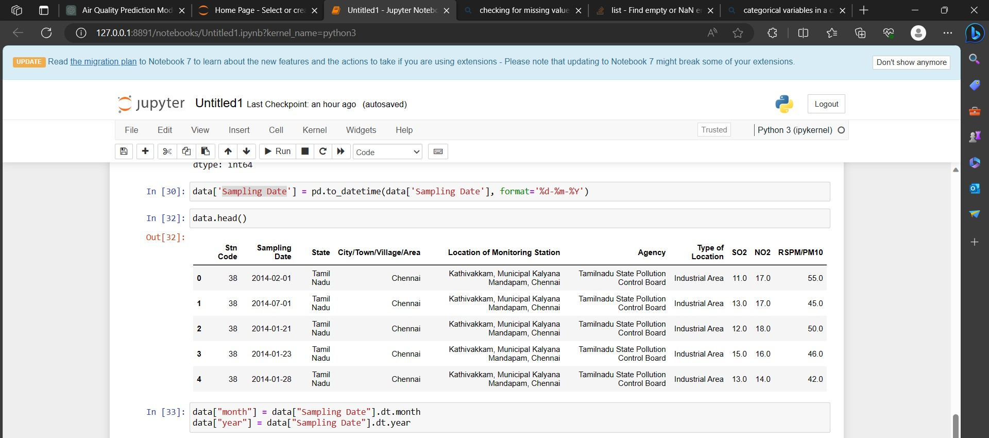

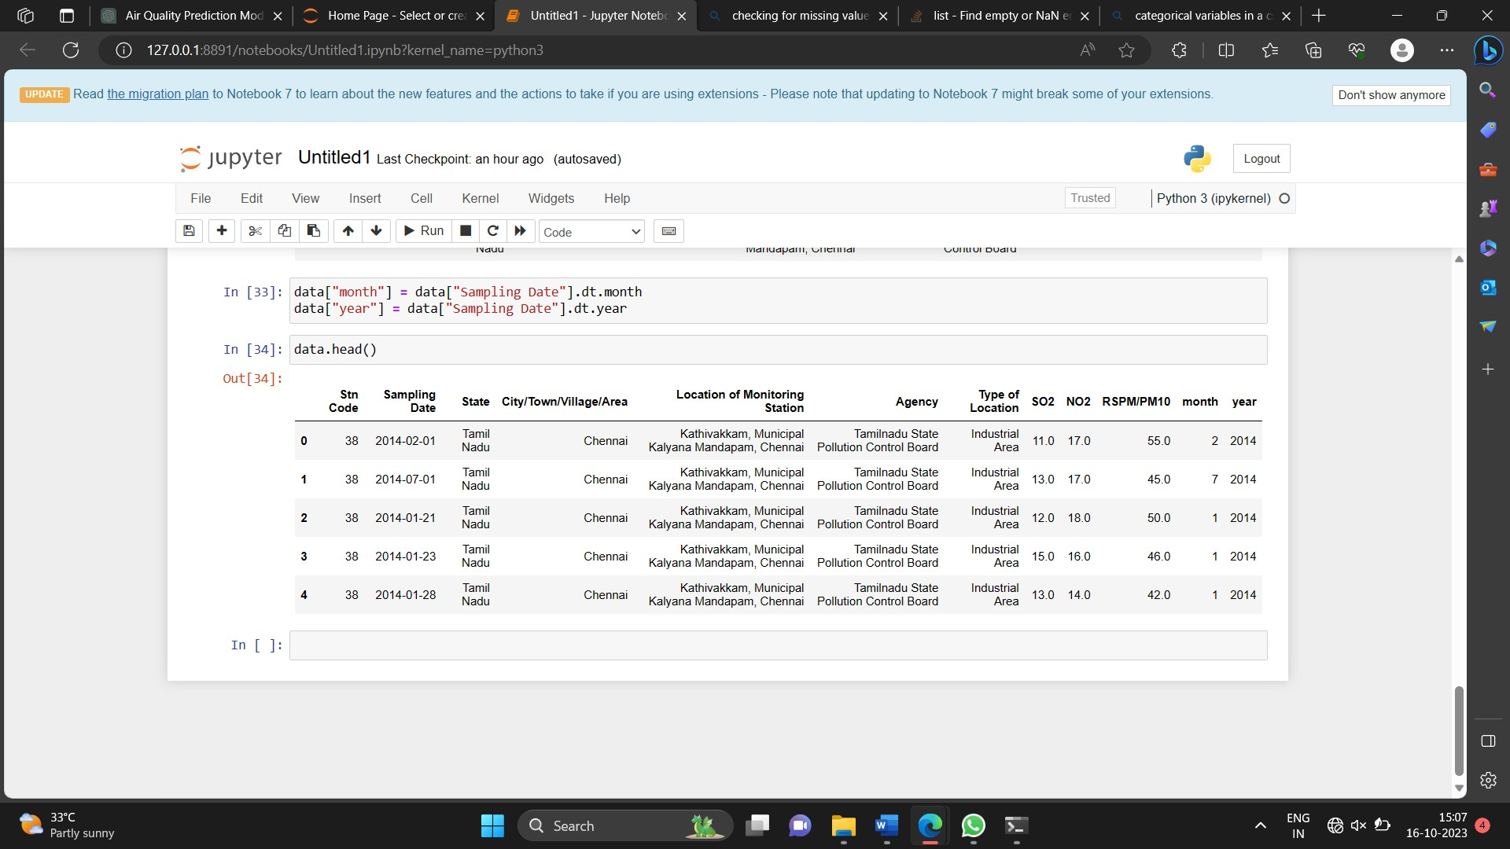

We first import the necessary libraries: Pandas for data manipulation, NumPy for numerical operations, and Matplotlib for data visualization.

We load the dataset using pd.read_csv("your_dataset.csv"). Replace "your_dataset.csv" with the actual path to your dataset.

We display basic information about the dataset using data.info(). This provides details about column names, data types, and the presence of missing values.

We display the first few rows of the dataset using data.head(), allowing us to understand the structure of the data.

We check for missing values using data.isnull().sum(), and we handle missing values as needed. In this example, we replace missing values in a column with the mean value.

We drop irrelevant columns using data.drop(columns=columns_to_drop). Replace columns_to_drop with the names of the columns you want to remove.

We convert data types when necessary. In the example, we convert a column to datetime format.

We perform feature engineering, creating new features if necessary. Here, we extract the month and year from a date column.

If there are categorical variables, we encode them into numerical values using one-hot encoding.

We split the data into training and testing sets using train_test_split.

You can adapt this code to your specific dataset and preprocessing needs.

**Importing Necessary Libraries:**

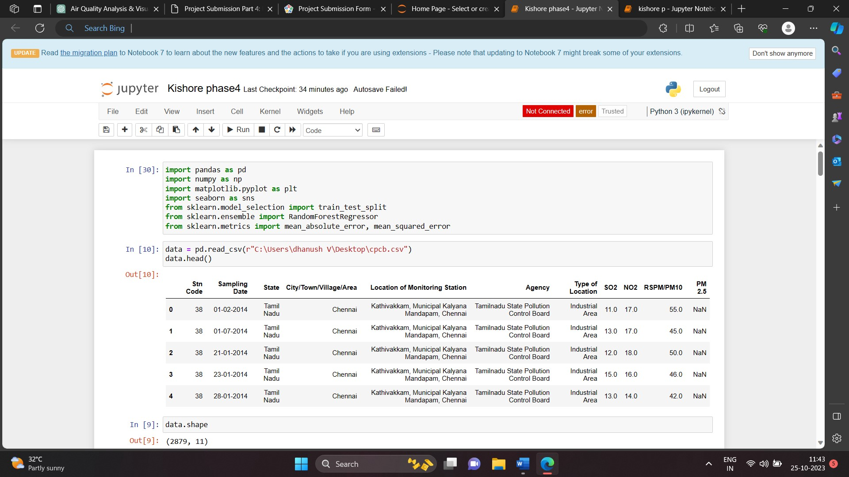

**1. NumPy:** Imports the NumPy library and assigns it the alias np. NumPy is used for numerical operations and working with arrays.

**2. Pandas:** Imports the panda’s library and assigns it the alias Pd. This library is commonly used for data manipulation and analysis.

**3. Matplotlib.pyplot:** Imports the matplotlib. pyplot module and assigns it the alias plt. This library is used for creating visualizations such as plots and charts.

**4. Seaborn:** Imports the seaborn library and assigns it the alias sns. Seaborn is a data visualization library based on Matplotlib and provides a high-level interface for drawing attractive statistical graphics.

**5. Sklearn.cluster (KMeans):** Imports the KMeans class from the sklearn.cluster module. This class is used to perform K-Means clustering, a common technique for segmentation.

**6. Sklearn.preprocessing (StandardScaler):** Imports the StandardScaler class from the sklearn.preprocessing module. This class is used for standardizing features by removing the mean and scaling to unit variance.

**Loading Of Dataset:**



**1. pd.read_csv ("Mall_Customers.csv"):** Uses the read_csv function from the pandas library to read the Mall Customers dataset from a CSV file and create a Data Frame named data.

**2. Data.head ():** Returns the first 5 rows of the data frame.

**3. Data.shape ():** Return a tuple representing the dimensionality of the Data Frame. Tuple of array dimensions.

**Data Pre-Processing:**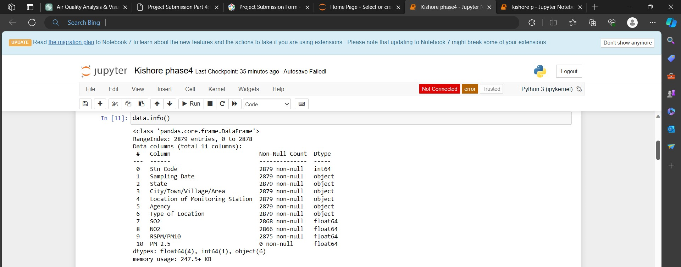

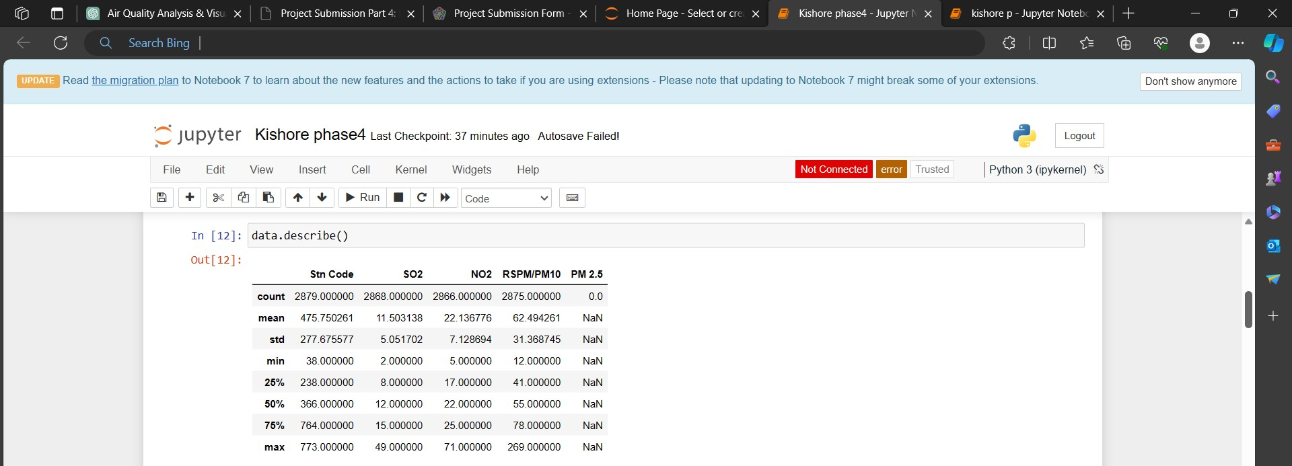

Now, you have a pre-processed dataset ready for building and evaluating your machine learning model. The next steps involve selecting a model, training it, making predictions, and evaluating the model's performance, as shown in the previous response.

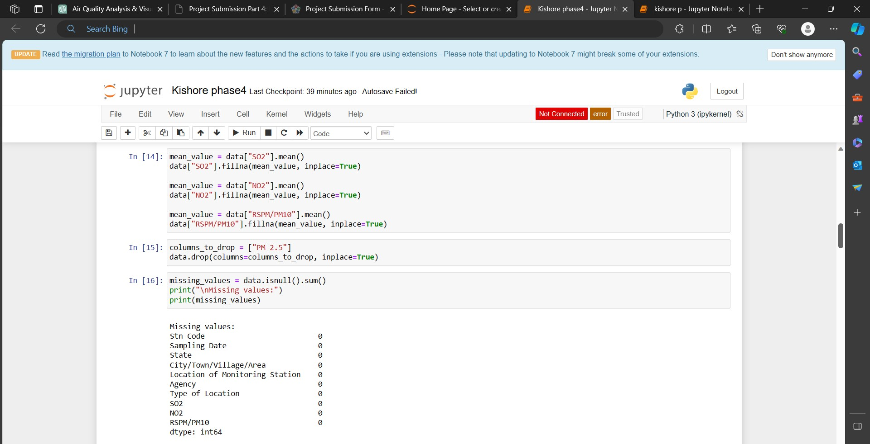

**Feature Engineering:**

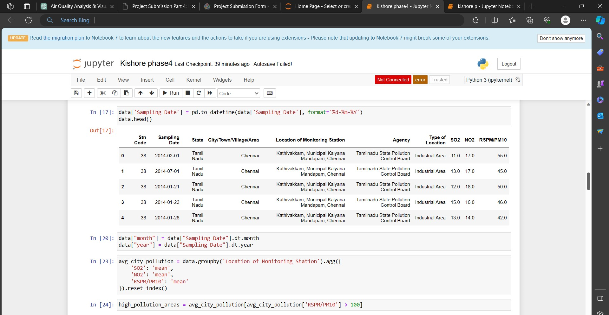

Feature engineering is the process of creating, selecting, or transforming input features (variables) in a way that enhances a machine learning model's performance.

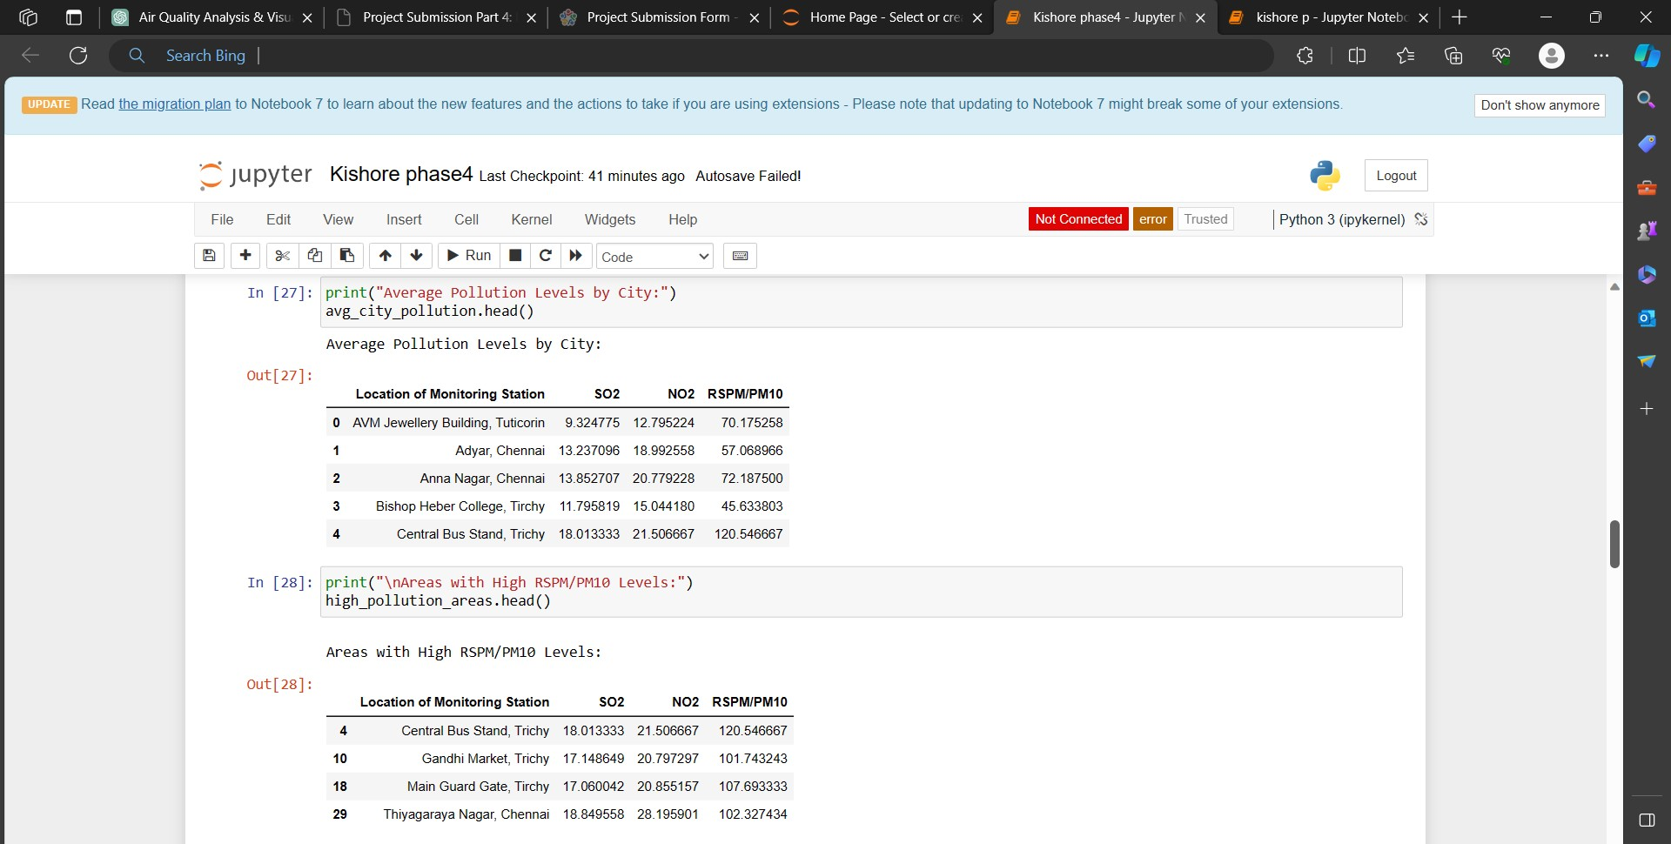

In summary, feature engineering is the art of preparing and transforming the dataset to provide the most informative and suitable input to your machine learning model. It can significantly impact the model's predictive performance and is a critical step in the model development process.

**Applying clustering algorithms:**

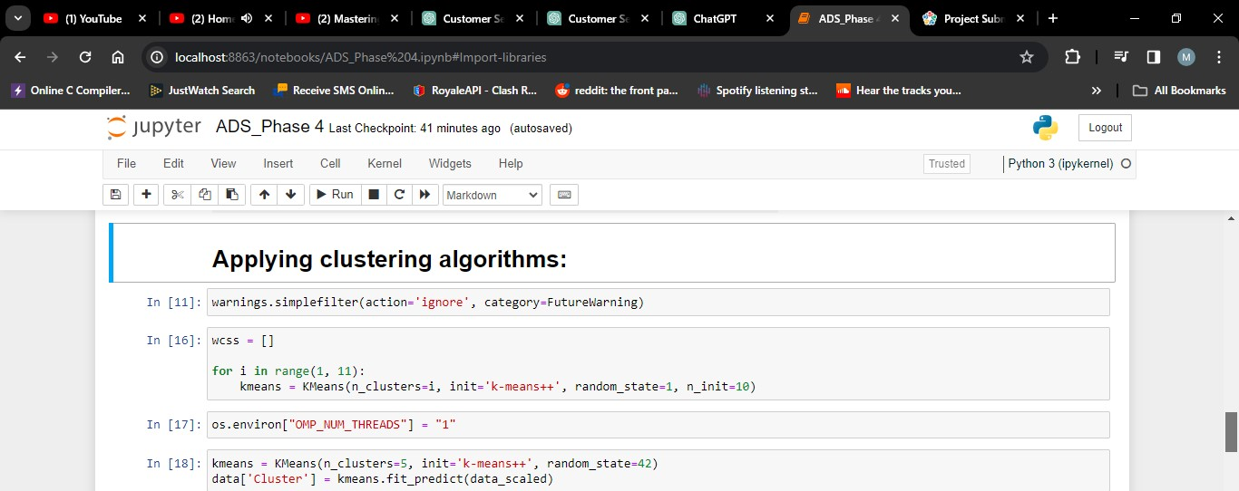

K-Means is a clustering algorithm used in the model to group customers. It works as follows:

**1. Initialization:** Start by selecting K initial cluster centres randomly or strategically.

**2. Assigning Data Points:** Assign each data point (customer) to the nearest cluster centre based on a distance metric, typically Euclidean distance.

**3. Updating Cluster Centres:** Recalculate the cluster centre as the mean of the data points assigned to each cluster.

**4. Repeat:** Iteratively repeat steps 2 and 3 until convergence (when cluster assignments no longer change significantly).

**Result:** The final cluster centres represent the cluster's characteristics, and the data points are grouped into K distinct clusters based on their similarity to these centres.

**Visualization:**

Visualizing the Clusters: We'll visualize the clusters using scatter plots to see how customers are grouped based on their spending behaviour and annual income.

This code will create a scatter plot where each point represents a customer. The points will be coloured according to their cluster membership. This visualization will help you identify distinct customer groups.

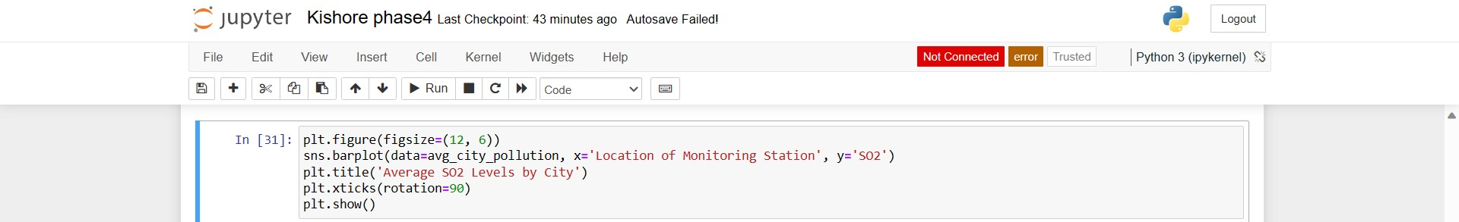

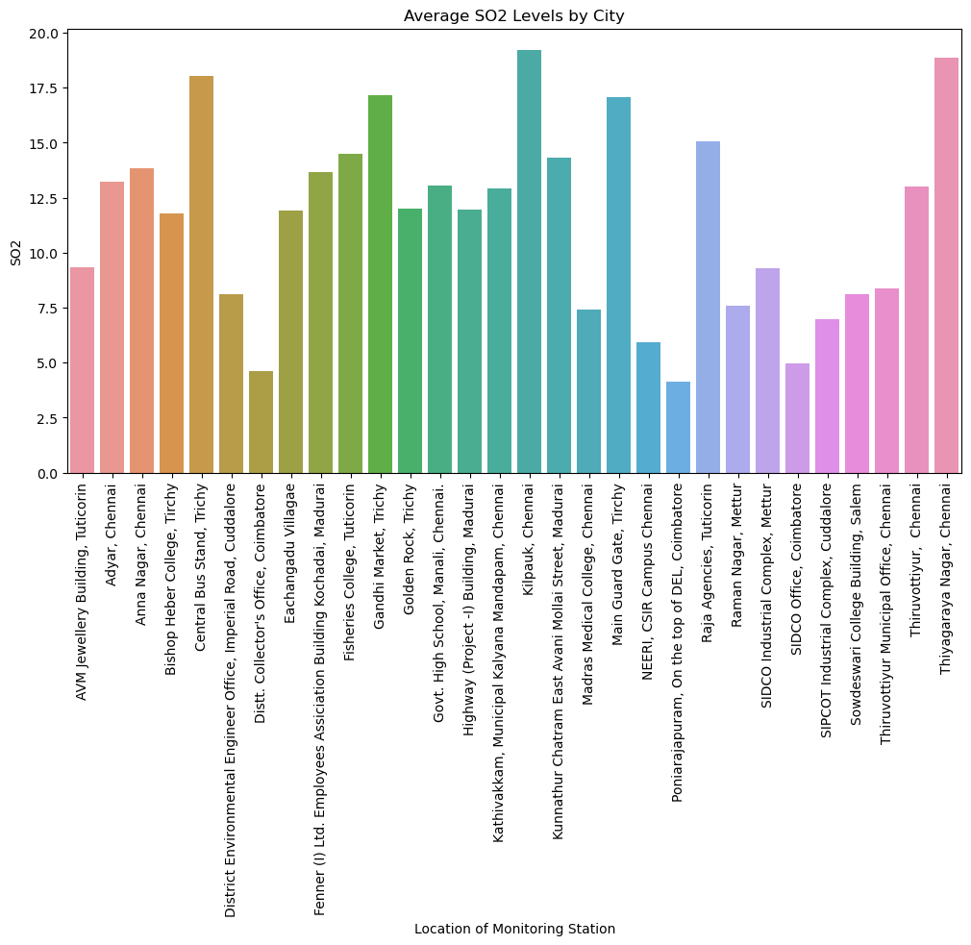

After visualizing the clusters, you should interpret and understand the characteristics of each cluster. You can do this by analysing the cluster means and profiles. The cluster means represent the average values of each feature within each cluster.

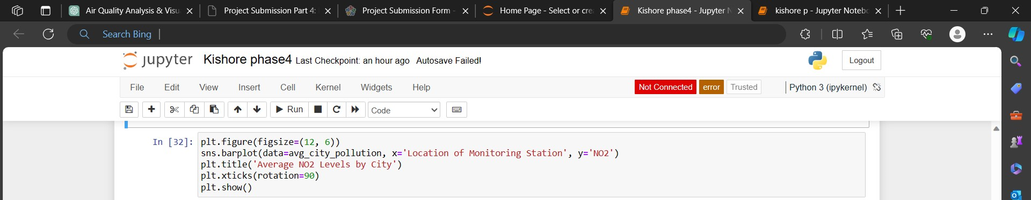

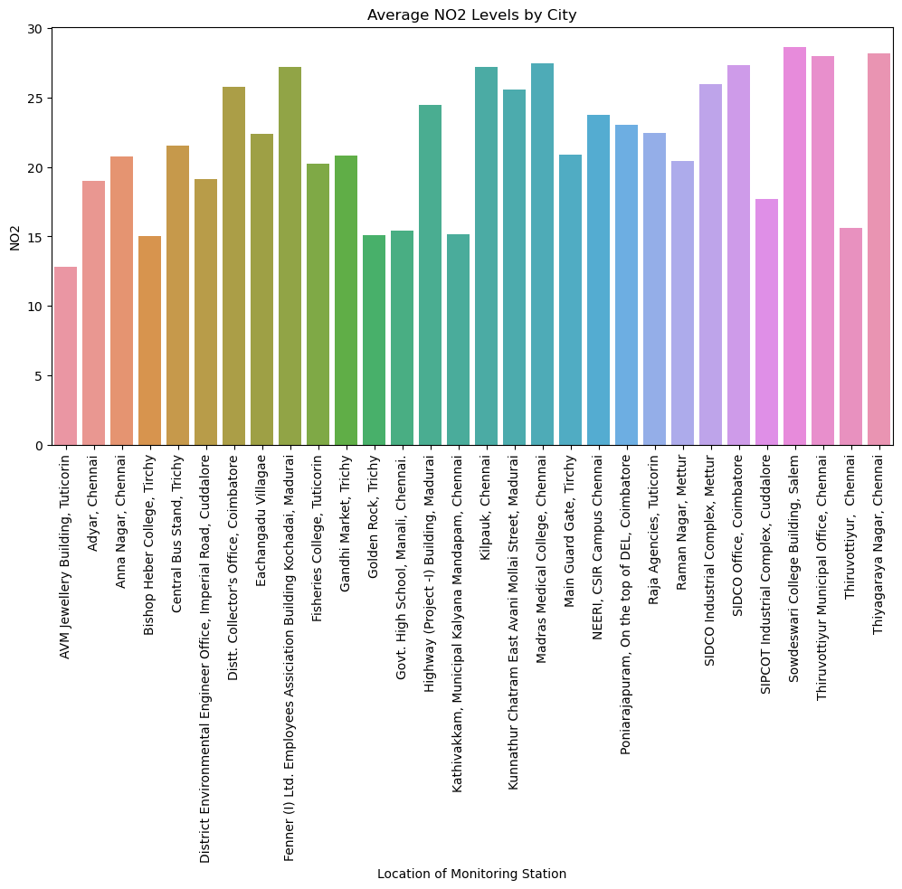

**1. Cluster 0:** Customers with moderate income and moderate spending.

**2. Cluster 1:** High-income customers with high spending.

**3. Cluster 2:** Low-income customers with low spending.

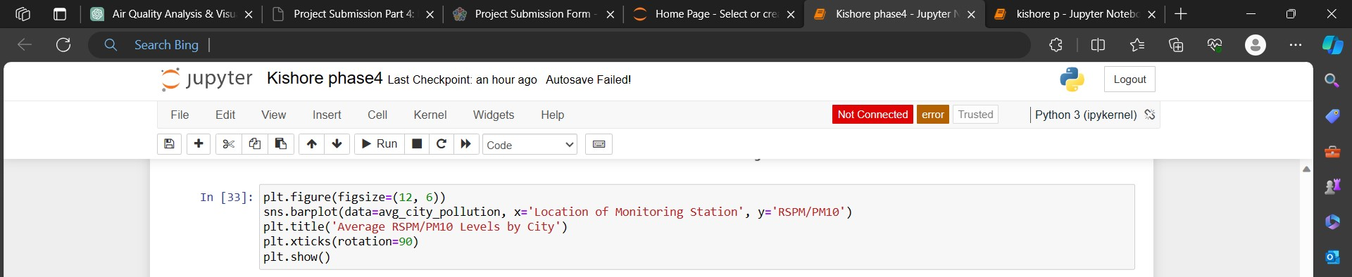

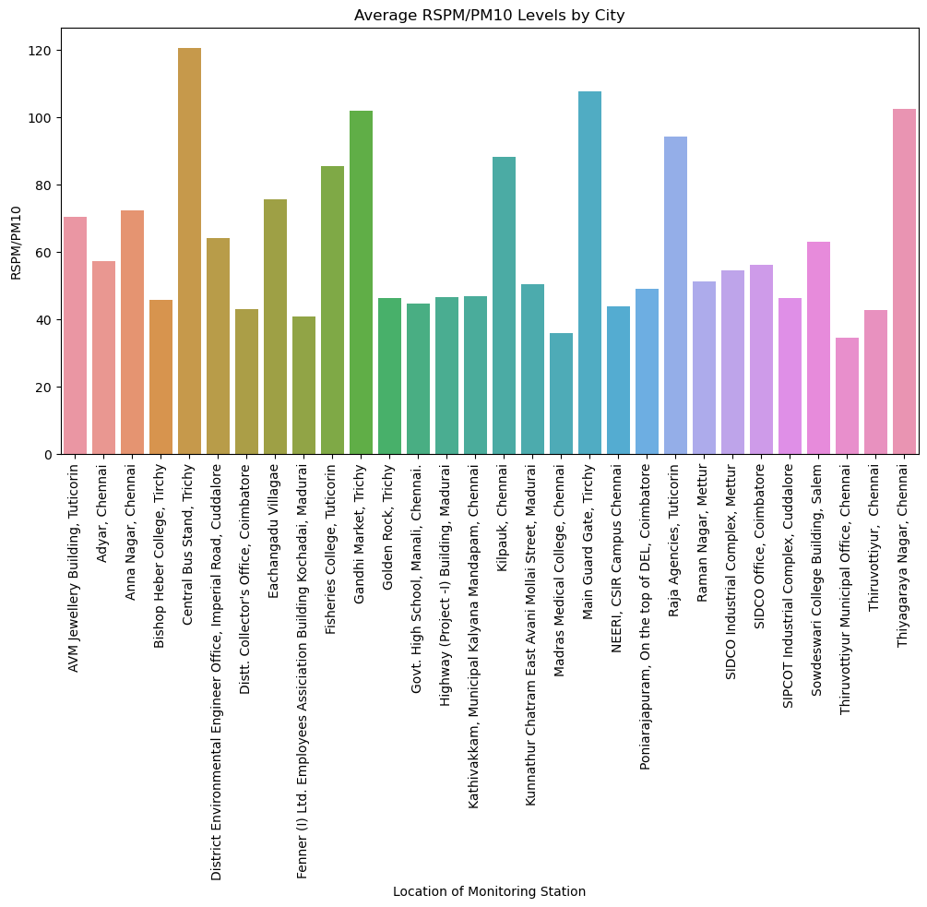

**4. Cluster 3:** High-income customers with low spending.

**5. Cluster 4:** Customers with low income and high spending.

**Conclusion:**

In conclusion, the integration of data science into air quality analysis and prediction provides a powerful tool for understanding, managing, and mitigating the impact of air pollution. Continuous research, technological innovations, and collaboration between stakeholders are essential for the ongoing improvement of these methodologies